**[What Does CCleaner Do, and Should You Use It?](http://www.howtogeek.com/172820/beginner-geek-what-does-ccleaner-do-and-should-you-use-it/" \o "What Does CCleaner Do, and Should You Use It?)**

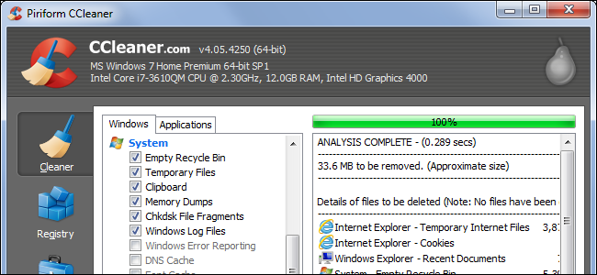

These days, it seems like every Windows user has heard about [CCleaner](https://www.piriform.com/ccleaner). It’s widely recommended, online and offline. But what exactly does CCleaner do, should you use it — and how often?

CCleaner has two main uses. One, it scans for and deletes useless files, freeing up space. Two, it erases private data like your browsing history and list of most recently opened files in various programs.

CCleaner Is Disk Cleanup On Steroids

Windows includes a [Disk Cleanup tool](http://www.howtogeek.com/125923/7-ways-to-free-up-hard-disk-space-on-windows/), although [it’s a bit hidden](http://www.howtogeek.com/164484/10-useful-system-tools-hidden-in-windows/). This tool frees up space on your hard drive by deleting useless files — old temporary files created by programs, temporary Internet files for Internet Explorer, Windows error report logs, and more. You can run this tool at any time to free up disk space.

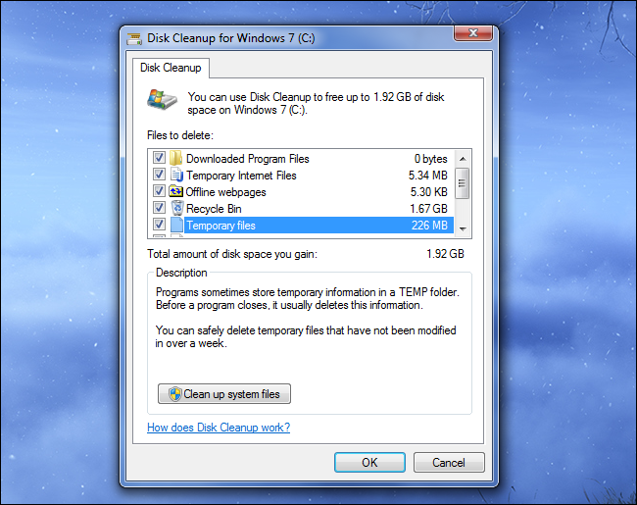

However, Disk Cleanup doesn’t go as far as it could. For example, while it can delete Internet Explorer’s cache files, it won’t touch cache files for other browsers like Chrome and Firefox. It won’t delete the useless setup folders NVIDIA’s graphics driver installers create when you update your graphics drivers, which can consume hundreds of megabytes each.

[CCleaner](https://www.piriform.com/ccleaner) does do these things and more. It takes the Disk Cleanup concept and runs with it, extending it to more data in Windows and third-party programs that the Windows Disk Cleanup tool won’t touch.

Just select the types of data you want to delete, click the Analyze button, and look over the data CCleaner will delete. If you’re happy, click the Run Cleaner button to actually delete the selected files. CCleaner will remember your choices for next time, so you can just open it and click the Run Cleaner button in the future.

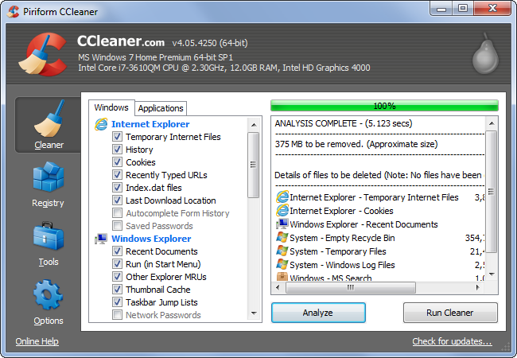

CCleaner Also Deletes Private Data

CCleaner has two main uses. It frees up disk space by deleting junk files and wipes out private usage data. For example, CCleaner will erase your browser history, cookies, and cache files for any browsers you have installed — Internet Explorer, Firefox, Chrome, even Opera. It will go beyond that, erasing the cookie data stored by the Flash Player. It will even wipe out other potentially privacy-risking data, such as the list of recently opened file names in Microsoft Word, Adobe Reader, Windows Media Player, VLC media player, and other common Windows applications.

All of this is customizable, but CCleaner is set up to wipe out this data by default. Not only does CCleaner quickly wipe away useless temporary files, it’s like a sort of computer-wide “Delete my history” feature that deletes more than just your browsing data. Of course, CCleaner doesn’t know about every program you might use, so this will never be perfect.

Why Running CCleaner Every Day Could Slow Down Your Web Browsing

You could use CCleaner constantly, running it every day with the default settings. However, this would actually slow your computer down in real use. This is because CCleaner is set up to delete your browser’s cache files by default.

Cache files are bits of web pages — images, scripts, stylesheets, HTML files, and more — that [your browser holds onto](http://www.howtogeek.com/138456/htg-explains-why-is-my-browser-storing-all-this-private-data-anyway/). For example, when you visit How-To Geek, your browser downloads the How-To Geek logo that we display at the top of the page. It then saves this logo in its cache. When you navigate to a different page on our website, your browser doesn’t have to download the logo image all over again — it just loads the image from the browser’s local cache. Your web browser is constantly doing this with bits of different web pages, and it speeds up web page loading because your browser doesn’t have to download the same files over and over.

However, if you were to constantly clear your browser’s cache, it would have to re-download the same files over and over. That means that clearing your browser’s cache constantly is a bad idea for performance reasons — constantly emptying the cache means you lose the benefits of having one.

Of course, the cache can also be a privacy concern. Someone with access to your computer could inspect your browser’s cache files to see what websites you’ve been visiting, just as they could look at your browser history. This is why browsers don’t save cache files when you browse in private-browsing mode.

If you want to run CCleaner regularly and aren’t worried about people with access to your computer snooping on your browsing, you should disable the Internet Cache-clearing options.

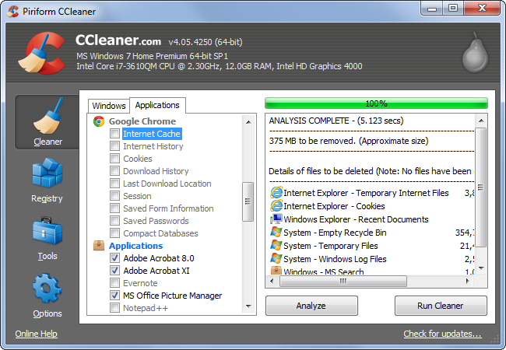

Will Using CCleaner Speed Up My PC?

There’s a lot of snake oil out there — unscrupulous [“PC cleaning” programs](http://www.howtogeek.com/162683/pc-cleaning-apps-are-a-scam-heres-why-and-how-to-speed-up-your-pc/) that want to sell you an amazing solution that won’t actually work as advertised. So you should exercise caution when it comes to system tools, especially ones that cost money.

However, occasionally cleaning temporary files — whether with CCleaner or the Disk Cleanup tool included with Windows — can help speed up your PC a bit. Many geeks can attest to computers performing more quickly after they wiped away useless junk files, and [even Microsoft says](http://smallbusiness.support.microsoft.com/en-us/gw/speed-up-my-slow-computer-2806116) “old cached and temporary files” can cause your computer to slow down.

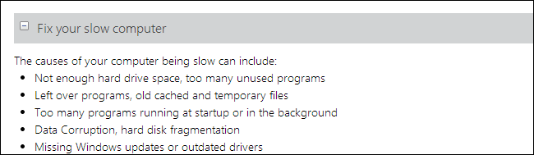

Why this works is unclear — certainly, if your computer’s hard drive is very full, freeing up space will help it perform faster. If your computer has an SSD, [that SSD will slow down as it fills up](http://www.howtogeek.com/165542/why-solid-state-drives-slow-down-as-you-fill-them-up/) — so ensuring you don’t have lots of wasted space is a good idea. Some programs may be badly written and may choke when they have lots of temporary files, antivirus software may insist on scanning the junk files and slowing things down, or Windows itself may have issues with a large amount of files for some reason — we’re not completely sure why this is.

The short answer is that occasionally deleting useless temporary files can help your PC stay fast — who are we to argue with Microsoft, who insist that this can help speed up your PC? — but you don’t have to run it constantly. Once a week should be more than enough, and even Disk Cleanup will do a lot on its own.

If you have an old PC that you’ve never run CCleaner or even Disk Cleanup on, you should give it a go — you’ll likely free up a lot of space and may even notice a performance improvement.

Choosing What to Clean

If you do end up using CCleaner, you can select the types of data you want it to remove from the Cleaner tab. The Windows section contains options for cleaning data included with Windows, while the Applications section contains cleaning options for third-party applications you have installed. Be sure to check the Applications section — if you don’t want CCleaner constantly wiping your browser’s cache, you’ll need to disable that option there. CCleaner will also wipe out all your website logins if you have it clear your browser’s cookies, which will force you to log into websites you use over and over.

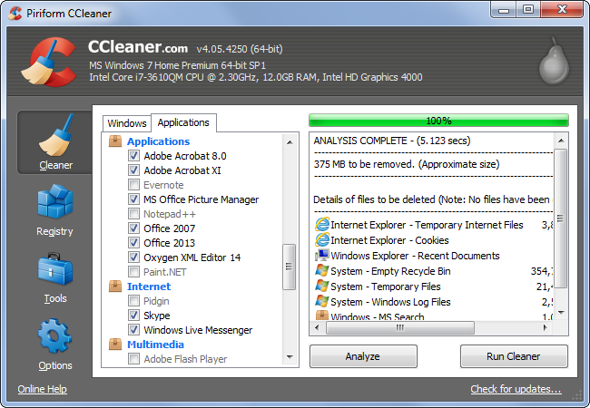

Advanced Stuff

CCleaner has a number of other advanced features, from managing your startup programs and locating duplicate files to securely wiping disks. You could also set CCleaner up to run automatically on a schedule. We’ve previously covered [using CCleaner’s more advanced features](http://www.howtogeek.com/113382/how-to-use-ccleaner-like-a-pro-9-tips-tricks/) and setting [up a scheduled task to run CCleaner automatically](http://www.howtogeek.com/howto/windows-vista/setup-ccleaner-to-automatically-run-each-night-in-vista-or-xp/).

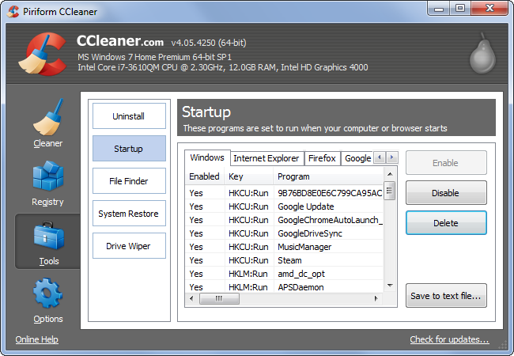

CCleaner is the best Windows application for deleting temporary files and wiping out usage data. Everyone can benefit from occasionally cleaning up their temporary files, so CCleaner is useful — although the Disk Cleanup tool included with Windows can do some of this on its o